Name:
About Me
Year 7 Virtual Transition Booklet
ABOUT ME
Name:

Tell us about yourself to help us get to know a little bit about you.

Hobbies:
……………………………………………………………………………………………………………………………………………………………………………………………………………………

Favourite subjects:
……………………………………………………………………………………………………………………………………………………………………………………………………………………

What do you want to be when you are older?
……………………………………………………………………………………………………………………………………………………………………………………………………………………

What are you interested in outside of school?
……………………………………………………………………………………………………………………………………………………………………………………………………………………

What things don’t you like?
……………………………………………………………………………………………………………………………………………………………………………………………………………………

Describe yourself in 3 words: ……………………………………………………………………………………………………………………………………………………………………………………………………………………

You will learn a huge number of new skills at secondary school, and improve skills you have learnt in primary school. In the goal below, write in 8 new skills or things you would like to build on in your years at secondary school.
Use the list below to help if you are stuck.

Be in a school play or production | Speak another language | Represent your school in a sports competition
Learn to play a musical instrument | Volunteer in the local community | Travel to another country
Play for a school team | Use the school library regularly | Take care of the school grounds
Learn how to manage money | Taste food from another country | Captain a sports team
Cook a new meal from scratch | Read new books | Take part in a non-uniform day
Create a piece of art | Raise money for charity | Be healthier
Learn how to read a map | Join an after-school club | Learn to dance
Use computers to create your own website | Become a student leader | Improve your singing
Make new friends from other schools | Work as part of a team | Achieve a reward in achievements assembly

Build your team
Your task is to construct a team. You must pick 5 different roles and one characteristic they will need to have. The first has been done for you. Great teams work best when everybody understands their individual roles and how this helps them to succeed.

1. Captain – Communication
2………………………………………….
3………………………………………….
4………………………………………….
5………………………………………….

You need to give your team a name:
…………………………………………………………………………………………

What are the rules of your team? These should include the way you behave towards each other and those around you.

Rules
1 ………………………………………………………………………………..
2 ……………………………………………………………………………….
3 ………………………………………………………………………………..
4 ………………………………………………………………………………..
5 …………………………………………………………………………………
6 …………………………………………………………………………………

What is your mission statement/motto? What are you about? What do you stand for?

Your Mission Statement
…………………………………………………………………………………………………………………………………………………………………………………………………………………………………………………………………………………………………………………………………………………………………………………………………………………………………………

Design your team logo
Using the shield below create a team logo. Each quarter of the shield should represent a moral or rule of your team.
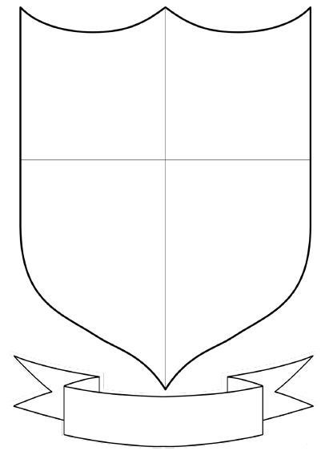

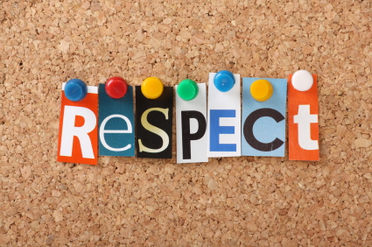
- Esteem: the condition of being honoured;
- An attitude of admiration or esteem;
- Obedience;
- Regard: a feeling of friendship and esteem.
The above are ways to describe RESPECT.
Write your own definition for respect:
………………………………………………………………………………………………………………………………………………………………………………………………………………………………………………………………………………………………………………………………
Who do you respect? Why?
……………………………………………………………………………………………………………………………………………………………………………………………………………………
Why is respect important?
………………………………………………………………………………………………………………………………………………………………………………………………………………………………………………………………………………………………………………………………

