Build your own Saturn V rocket! You need this sheet, a pencil, a straw and tape.
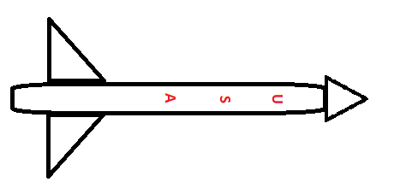

Step 1 – Roll the square around a pencil. When tight and a cylinder shape, tape it so it does not unravel.
Step 2 – Cut out the circle and the small piece inside of it. You should be left with something that looks like pacman. Now take the circle and fold the flaps down to make a cone. Make sure your cone is really tight and then tape it together.
Step 3 – Place the cone on one end of your cylinder shape you made in step 1. Tape it in place, so that it sits on top.
Step 4 – Cut out the triangles as these are the wings. Tape them to your rocket as shown in the picture below.
Step 5 – Place a straw into the bottom of your rocket and blow into the straw!!!

