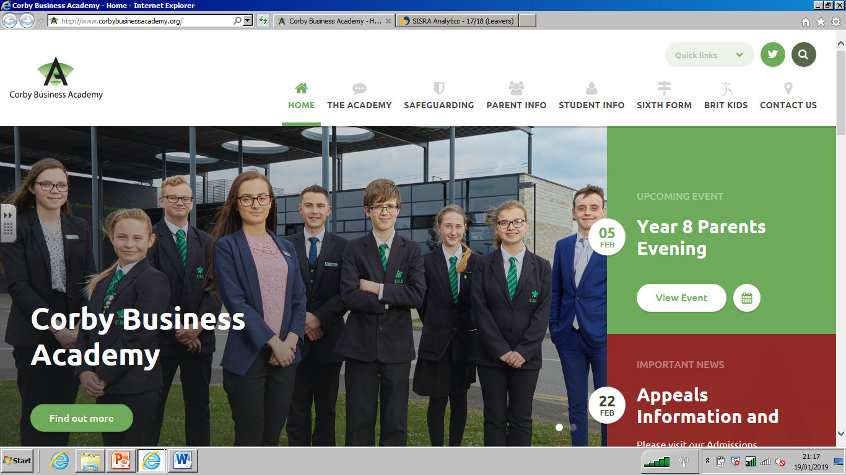

|  |
| --- |
| A Level Business/BTEC Level 3  Preparation for Sixth Form Summer Work |



**A Level Business/BTEC Level 3**

**Solving a business problem**

During the summer, months there are many Festivals taking place in the UK. At the end of the event, there are thousands of tents and camping equipment abandoned by festivalgoers.



**The Task:**

You have been tasked with writing a report, advising the Festival organisers how to deal with the aftermath of the event. You must bear in mind that you are a business.





**Report Structure:**

As a business, you will need to consider the following:

* The name of your business
* What would be the objectives for the task?
* Identify what your problems might be – set the scene
* Your proposal – with an explanation of how you are going to resolve the challenge

You should consider the following:

* 1. **Resources required:**
* Human – who you may need to support you
* Financial – an overview of costs involved, Income you could receive. Alternatively, are you going to be charitable?
* Physical resources – materials and equipment needed.
  1. **Marketing:**
* Selling – How are you going to dispose of what you have?
* Promotional Material – any flyers, advertisements you may need to design

At the end of your report, you should summarise your recommendations.

A Minimum of 1,000 words.