Corby Business Academy
A level music

GCSE to A Level Transition Booklet

Edexcel A level Music

Choosing Music A Level
Music at A level is varied, practical, and intellectually stimulating. GCSE is not necessarily a prerequisite but being proficient on an instrument is.
You will hone numerous skills; listening, analysing, essay writing, and forming arguments, alongside the creative skills Music fosters so successfully. This marriage of skills makes Music A Level a respected and well-rounded qualification. We also aim to deliver the qualification in an engaging and practical manner, through performance and composition tasks which link to the set works.
Top tips for the course
- Listen to as much music as you can. Vary the genre, explore composers and artists you have not previously listened to.
- Begin to discover a basic history of music; eras, composers, particular features of genres. Read books and do some research online.
- Revise how to read staff notation and basic music theory. Grade exams are not necessary but an understanding of how to read music and knowledge of theoretical concepts will help.
- Perform as much as you can!
- Compose without the fear of doing it ‘wrong’! Find a way which works for you: with an instrument, at the piano, using technology, or even paper and pencil!

Every subject at A Level is a step up from the GCSE qualification. Remember that we have two years to cover the course content and consolidate the knowledge and skills required. We structure the set works and course to ensure the transition is as seamless as possible, with good progression from GCSE.

This booklet will give an overview of the whole course, as well as some suggestions of how you can begin to prepare for the transition from GCSE to A level. The tasks and recommendations are merely suggestions but have been designed to give you a complete preparation for the course.

What does the course consist of?
Three components make up Edexcel A Level Music, as shown below:
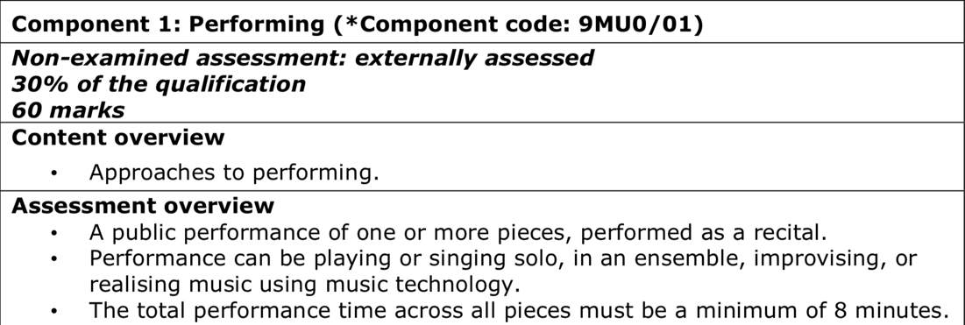
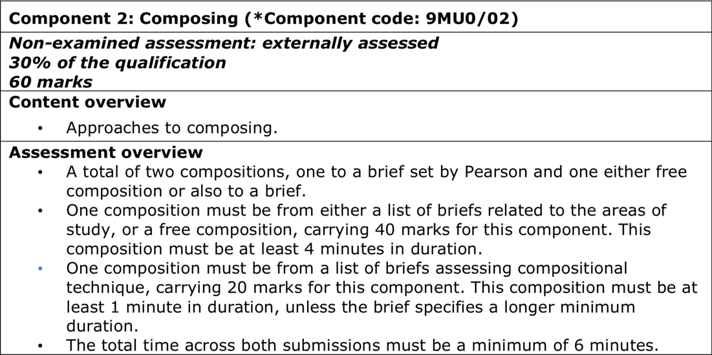
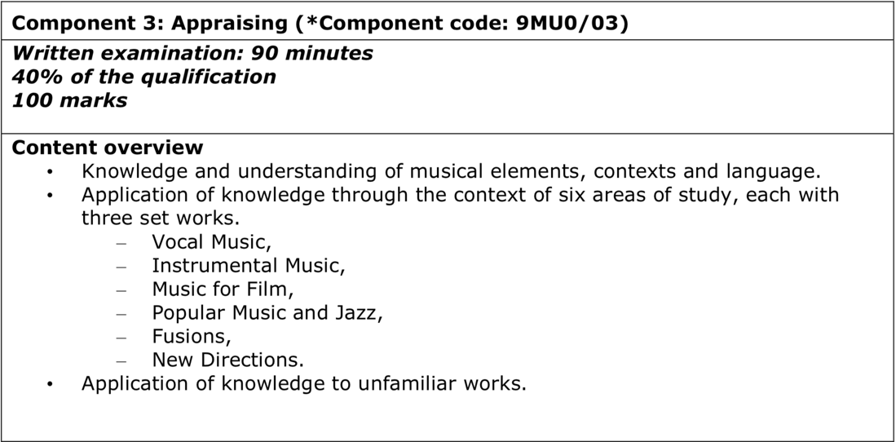

How to prepare for Component 1 (Performance)
On or after 1st March of Year 13, a recital lasting 8 minutes will be recorded. Your performance can be solo or ensemble and music should be of the highest difficulty you can play accurately, fluently, and expressively.
There is a significant mark boost available for performing pieces which are Grade 8 (more difficult) and a slight increase for Grade 7 pieces (standard difficulty). No additional marks are awarded for Grade 6 level pieces.
Performances are recorded and marked by an external Edexcel examiner. The 60 marks available for performance are awarded across three areas:
- Technical control
- Accuracy and fluency
- Expression and interpretation

So what can you do?
- Have regular lessons with a peripatetic teacher
- Practise and perform regularly. Take opportunities to perform in front of an audience
- Focus as much on expression (dynamics and articulation) as accuracy and fluency. There are a lot of marks for expression alone
- Choose repertoire which shows you at your best. Pieces do not have to be classical; it’s the level of difficulty and how accurately and expressively you can perform that matters
- Join school ensembles, especially with the voice/instrument you intend to use for A level performance

If you wish to check the level of difficulty for pieces you know or are in the process of learning, Edexcel have made the resource below to help:
https://qualifications.pearson.com/content/dam/pdf/A%20Level/Music/2016/Specification%20and%20sample%20assessments/GCSE-AS-and-A-level-Music-Difficulty-Levels-Booklet.pdf

How to prepare for Component 2 (Composition)
Composition is broken down into two sections, shown below:
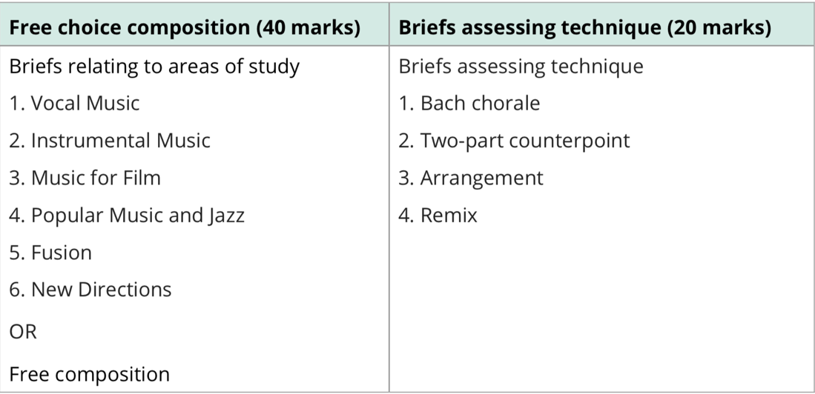
You will complete the Bach Chorale for the Technical Study (20 marks).
Much like GCSE Music, students choose one of a selection of briefs relating to the areas of study or students can choose to complete a free composition for which they will need to write their own brief for their chosen audience or purpose (40 marks).
The free choice composition should last a minimum of 4 minutes. The technical study should be at least 1 minute in duration, however, the Bach chorales are given to you so there is no option to change the length of the piece.
The Free choice composition is marked across 3 areas which are:
- Structure and developing musical material
- Response to the brief, with a sense for the audience and occasion
- The control and use of musical elements

What can I do to prepare?
- Compose in a range of styles
- Listen to as much music as you can and note any common features of particular styles
- Try not to overcomplicate it; keep it simple initially
- Create numerous small ideas rather than one large composition for now
- Find a way which works for you: with an instrument, at the piano, using technology, or even paper and pencil!

How to prepare for Component 3 (Appraisal)
Students will develop their listening and appraising skills through the study of music across a variety of styles and genres. The content is grouped into six areas of study, each of which contains three set works, shown below:
Area of Study | Set Works
Vocal Music | - Ein Feste Burg (movements 1, 2 and 8) - J.S. Bach  - The Magic Flute (excerpts from Act 1) - W.A. Mozart  - On Wenlock Edge (nos. 1, 3 and 5) - Vaughan Williams
Instrumental Music | - Concerto in D minor – Vivaldi  - Piano Trio in G minor (movement 1) – Clara Schumann  - Symphonie Fantastique (movement 1) - Berlioz
Music for Film | - Batman Returns (excerpts) - Danny Elfman  - The Duchess (excerpts) - Rachel Portman  - Psycho (excerpts) - Bernard Herrmann
Popular Music and Jazz | - Hounds of Love, Cloudbusting, Under Ice, and Dream of Sheep – Kate Bush  - Back in the Day: Inner State (of Mind), Lady Day (and John Coltrane) and Love and Affection – Courtney Pine  - Revolver: Here, there, and everywhere, I want to tell you, and Tomorrow never knows – The Beatles
Fusions | - Estampes Numbers 1 and 2 – Debussy  - Se quema la chumbamba and Alla va Candela – Familia Valera Miranda  - Burn, Breathing Under Water, Easy – Anoushka Shankar
New Directions | - Three Dances for Two Prepared Pianos No. 1 – John Cage  - Petals – Kaija Saariaho  - The Rite of Spring (excerpts) - Stravinsky

Short form listening questions and a 30-mark essay question will be based on these set works in the appraisal exam at the end of Year 13. We aim to perform the set works or complete short compositions based on similar techniques to make learning the analysis engaging and practical.
Preparing for Appraisal
- Listen to as much music as you can of a variety of genres
- As you listen, aim to do some basic analysis: time signature, tonality, instrumentation, melodic features etc.
- Create an extended piece of writing on some of your favourite pieces of music, creating an argument and evidencing it with musical features; E.g. The Beatles’ use of sonority was ground breaking or John Williams’ melodic writing for the Star Wars films has influenced film music since its creation.

Listening, performing, and composing
Now is a good time to make use of the many resources available online. Whether related to the set works or not, it is worth familiarising yourself with as much music as you can.
Here are some suggestions:

Full performance of Mozart’s ‘The Magic Flute
https://www.youtube.com/watch?v=02u4Jf_aNPI

Ted talks on many different areas of music
https://www.ted.com/playlists/browse?topics=music

BBC Radio 3
A variety of programmes and radio shows across numerous genres. Composer of the week is also useful.
Programmes: https://www.bbc.co.uk/schedules/p00fzl8t
Composer of the week: https://www.bbc.co.uk/programmes/p02nrvd3/episodes/downloads

San Francisco Symphony Orchestra
Podcasts and information on a variety of composers
https://www.sfsymphony.org/Discover-the-Music/Listen-to-Podcasts/Program-Notes-Series
Tasks
Performance
- Finesse a piece you know how to play well. Focus on expression and interpretation
- Start to learn a new piece with an emphasis on accuracy and fluency
- Perform a piece you know well and see how stylistic you can make it; know the features of the style in which you are playing
- Record yourself performing a piece you are familiar with. Analyse it critically with what you did well and what you need to improve
- Listen to a performance online / go to see a concert. What makes a successful performance other than accuracy and fluency?
Composition
- Write a composition using one pitch. For example, only use B but you are permitted to use different octaves.
- Take the following chord progression. Make the triads more complex by adding notes (e.g. sus4, 7th) and create a rhythm to play the chords to. Am G C F
- Create a 4 bar leitmotif on any instrument to represent a character from Greek / Roman mythology (Zeus, Hera, Hephaestus etc). Write a short paragraph explaining the musical features used to depict that character
- Explore various ranges, techniques, and characteristics of you first instrument. Can you create something interesting and unusual to exploit these characteristics of your instrument?
- Read the following blog: https://manwaringmusic.blog/2020/04/02/composing-at-home-1/

Appraisal
- Familiarise yourself with the DR T SMITH mnemonic for A level. Dynamics, Rhythm (metre and tempo), Texture, Structure, Melody, Instrumentation, Tonality, Harmony. Write as many keywords / features of those areas as you can. E.g. Rhythm may include syncopation, andante, hemiola.
- Choose a composer, a piece by that composer and listen to it. Why do you enjoy this piece? What musical features make it so satisfying? Give the composer, title of the piece, era of music e.g. Baroque.
- Argue the following question: “What’s the point of having music in a film?” Provide relevant musical examples of film music and come to some conclusion at the end of your writing. Aim to write a side of A4.
- Stockhausen said all music which is tonal (i.e. in a particular major or minor key) has already been written and that he would end up merely repeating music which had already been composed. To what extent do you think all tonal music has already been composed and we are merely repeating what already exists?
- ‘Popular music deserves more recognition and is equal to Classical music’. Discuss and provide relevant musical examples.
Reading
Music: A Very Short Introduction by Nicholas Cook
The Story of Music by Howard Goodall
A History of Western Music by Burkholder, Grout, and Palisca
ABRSM: The AB Guide to Music Theory, Part 1 or https://www.musictheory.net/lessons

