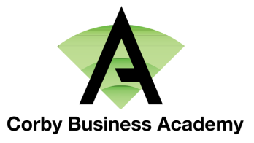
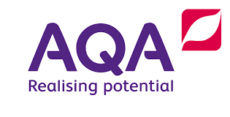

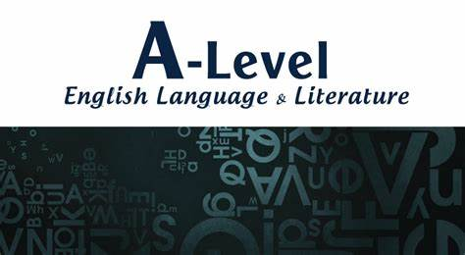

Introduction
Congratulations on choosing to study English at A-Level!
AQA English Language and Literature is the new A-Level we are offering at Corby Business Academy that offers you the best of both worlds: the chance to continue studying Literature but also to learn more about the study of English Language. It is an accessible and engaging combined course that will not only build on the skills you already have, but also encourage you to think critically and prepare you for whatever your next steps happen to be. It is well-respected by universities and employers and one we believe will enable you to fulfil your potential and succeed!
What is this booklet for?
This booklet will help you to start thinking like a student of English Language and Literature, someone who reads texts critically from the perspective of a linguist. The more you study English Language and Literature, the more you begin to inherit another sense, another power, to your personality that will always be able to see the nuances and ideas that hide behind language. You will be able to read any texts with a new level of analysis that you’ve never noticed before and form opinions using a far more informed, academic level of detail.
English Language - New Terminology
Studying English Language at A-Level is very different from GCSE English. The most challenging aspect of A-Level English Language can be getting to grips with the amount of terminology that you will be expected to know and use accurately.
Starting to create a working glossary document so that you can collect all the key terms you learn in one place makes it easier to revise in the future.
An AQA glossary of all the terminology you need can be found at the end of this booklet. Have a read through it and tick off terminology you have learnt before and are confident using, or that you are slightly familiar with.
Don’t be put off by the amount of terminology – by the end of the course, you will be able to use everything confidently!
Recommended Reading List
There are a lot of books written about English Language. Some of the most accessible include:
David Crystal: The Story of English in 100 Words; How Language Works; The English Language: A Guided Tour of the Language (in fact, most books by this author are accessible and interesting. Have a look in your local library for them.)
Bill Bryson: Mother Tongue
There are also some really useful blogs to have a look at:
https://blog.oxforddictionaries.com/ - gives some interesting insights into new words and the changing uses of existing words.
http://flashfictiononline.com/main/ - useful website for looking at short pieces of creative writing. https://www.theguardian.com/media/mind-your-language - interesting blog that looks at attitudes towards the ways in which language is used.
Language Scrapbook
The joy about studying English Language is that it is everywhere.
Your English Language set text is a wide selection of texts which are all connected to Paris.
They are made up of texts such as:
- Transcript for a Eurostar advert
- Extract from a Bill Bryson travel book and part of a Paris city guide
- Transcripts of people talking about visiting Paris
- Blogs and extracts from websites
- Cartoons and children’s history books

SUMMER TASK 1:
- As part of your summer work, start a ‘scrapbook’ where you collect different examples of language. For example: leaflets, food packaging, instructions, adverts…
- Annotate the examples looking at how they use language to meet the demands of the different audiences, forms and functions of the text.
- Have this ‘scrapbook’ with you in September to show your teachers.

For example:
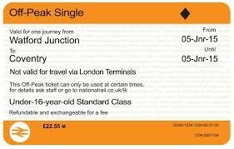

Jargon
–

Language unique to this type of text.
Demonstrates the cost of the ticket and implies
that it is cheaper than other types.

Abbreviations due to limited size of
Colours are typical of this text type
and are the same regardless of the
train company
.

Implied legal language showin
g the
authority of the ticket.
Hints at the
power behind the people who issue
and check tickets.

English Literature Content:

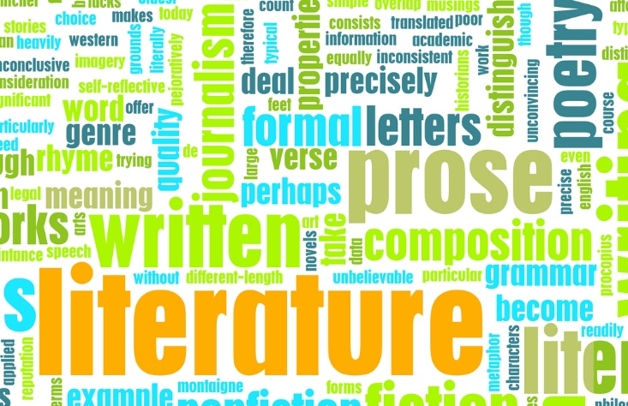
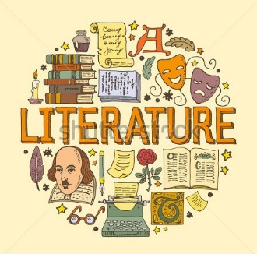

You will soon continue your journey further into the imaginings of some of the most famous, influential and important writers that are and have ever been. Initially, this can seem quite daunting as there is so much, but hopefully this guide will help you with some starting points to ease the transition from GCSEs to A Level.

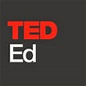
A good starting point is to watch this quick (quite blistering) synopsis of why we study Literature and a short TED Talk on Creating a Fictional World:
https://youtu.be/ZQTQSbjecLg?t=223
https://www.youtube.com/watch?v=MSYw502dJNY

From GCSE to A Level:
For English Literature, the shift from GCSE to A Level is often based upon the idea of independence. In English Literature the expectations will most likely be that you will take on a greater responsibility for your learning. What this means is that you will be having to come up with your own opinions and ideas about texts, discuss ideas without prompting and complete essays with fewer restrictions on how you approach the question compared with GCSE. You will be expected to complete work independently and quite often in advance of each lesson. You may also be required to deliver things such as short presentations and participate in seminars (discussion and debate based learning).
Recommended Reading:
One of the great things about English Literature courses is that they often introduce you to a wide array of amazing authors and texts. There is so much Literature that it can be bewildering to begin with. Instead of providing a comprehensive reading list, we have listed below some key suggestions for starting points of books that you might want to read, to begin gaining knowledge of wider Literature to both help your course and interests. However, there is much more out there. If you want to seek out more, the good news is that it is very easy to do so. Simply do an online search for anything like ‘English Literature A Level reading list’ and there will be hundreds (if not thousands) of books suggested. For now, here are a few pointers:
- Consider reading the books listed on your course you will study (those in bold) as well as the ones not in bold that you won’t study.

Imagined World Texts:
- Mary Shelley: Frankenstein
- Bram Stoker: Dracula
- Margaret Atwood: The Handmaid’s Tale
- Alice Sebold: The Lovely Bones

Writing about Society Texts:
- F. Scott Fitzgerald: The Great Gatsby
- Jon Krakauer: Into the Wild
- Kate Summerscale: The Suspicions of Mr Whicher or the Murder at Road Hill House
- Khaled Hosseini: The Kite Runner

Dramatic Encounters:
- Tennessee Williams: A Streetcar Named Desire
- William Shakespeare: Othello
- Arthur Miller: All My Sons
- Rory Kinnear: The Herd

SUMMER TASK 2:
As already stated, the best thing that you can do to prepare for studying English Literature is to read a wide range of good quality books. Choose a suitably challenging novel (from suggestions below) to read before your course, and then answer and prepare the following:
- Make notes of any ideas or techniques that the writer used that interested you. Put these into a short 5 minute presentation you could share with your class.

- Write a critical review of the text. Here is an example, a review of The Handmaid’s Tale in The Guardian: https://www.theguardian.com/books/2010/sep/26/the-handmaids-tale-margaretatwood

- Do a piece of creative writing inspired by the text – this should in some way mimic the style of writing of the author – and write a commentary on what key language choices you used to achieved this.

- Have these with you in September to show your teachers.

General Reading List:
It is impossible to create a fully comprehensive reading list for A Level Literature but here are a few authors and books that regularly crop up as coursework choices or on recommended reading lists:
Fiction:
Author | Book | Author | Book
Achebe, Chinua | Things Fall Apart | Hardy, Thomas | Tess of the D’Urbervilles
Atwood, Margaret | The Handmaid’s Tale | Ishiguro, Kazuo | The Remains of the Day
Austen, Jane | Pride and Prejudice | Kesey, Ken | One Flew Over the Cuckoo’s Nest
Banks, Iain | The Wasp Factory | McCarthy, Cormac | The Road
Barker, Pat | Regeneration | McEwan, Ian | Atonement
Brontë, Charlotte | Jane Eyre | Mitchell, David | Cloud Atlas
Brontë, Emily | Wuthering Heights | Morrison, Toni | Beloved
Burgess, Anthony | A Clockwork Orange | Orwell, George | 1984
Carter, Angela | The Bloody Chamber | Plath, Sylvia | The Bell Jar
Conrad, Joseph | Heart of Darkness | Smith, Zadie | White Teeth
Dickens, Charles | Great Expectations | Stoker, Bram | Dracula
Eugenides, Jeffrey | The Virgin Suicides | Tartt, Donna | The Secret History
Faulks, Sebastian | Birdsong | Wilde, Oscar | The Picture of Dorian Gray
Fitzgerald, F. Scott | The Great Gatsby | Woolf, Virginia | Mrs Dalloway
As with the suggestions previously, it is worth looking at other books by the same writers.
Poetry:
Poet | Poems
Blake, William | Songs of Innocence and Experience
Duffy, Carol Ann | Any
Eliot, T.S. | The Wasteland
Heaney, Seamus | Any
Hughes, Ted | Birthday Letters
Keats, John | The Odes
Larkin, Philip | The Whitsun Weddings
Owen, Wilfred | Any
Plath, Sylvia | Any
Wordsworth, William | Any
Various  (contemporary) | Poems of the Decade: An  Anthology of the Forward  Books of Poetry

Drama:

Playwright | Play
Beckett, Samuel | Waiting for Godot
Miller, Arthur | Death of a Salesman
Pinter, Harold | The Birthday Party
Shakespeare, William | Any
Stoppard, Tom | Rosencrantz and Guildenstern are dead
Williams, Tennessee | A Streetcar Named Desire
Wilde, Oscar | The Importance of Being Earnest

Assessment Writing
One of the biggest fears that many students have is the first assignment or essay that they get. Whilst this is a daunting experience, be assured that you are on a course which will be guiding you on how to improve your writing. No-one is expecting you to write perfectly from day one. Here are a few pointers to help with this:
- Make sure that you have checked exactly what is required of you for the task itself – details such as if there is a word-count requirement and specifics such as what areas of the text you are focusing on.
- Speak to your teachers – they are there to help and will be able to guide you.
- Plan and prepare – you must give yourself plenty of time to think and to write. Plan out your time and do not leave it until the last minute.
- Review and edit – once you have finished writing you must always give yourself a good amount of time to check through your response for both aspects such as SPAG checking but also checking that you have covered the question properly.

Understand the Assessment Objectives:
Assessment objectives are the different skills that the examiner is going to judge in your work. It is helpful to know what they are from the start of your course in order to gain marks and write successful responses. The actual assessment objectives are:

AO1 | Apply concepts and methods from integrated linguistic and literary study as appropriate, using associated terminology and coherent written expression
AO2 | Analysis of ways in which meanings are shaped in texts
AO3 | Demonstrate understanding of the significance and influence of the contexts in which texts are produced and received
AO4 | Exploring connections between texts, informed by linguistic and literary concepts and methods
AO5 | Demonstrate expertise and creativity in the use of English to communicate in different ways.

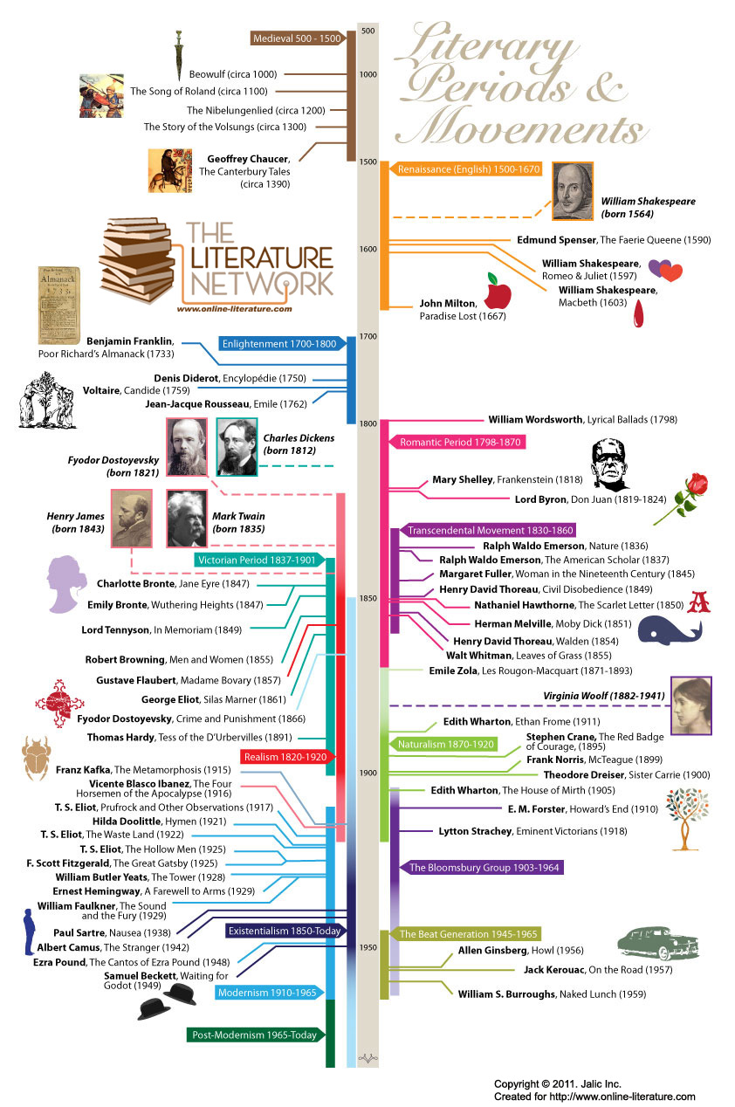
AQA ENGLISH LANG/LIT

KEY LITERARY PERIODS IN ENGLISH LITERATURE

Old English (Anglo-Saxon) Period (450–1066)
The term Anglo-Saxon comes from two Germanic tribes: the Angles and the Saxons. This period of literature dates back to their invasion (along with the Jutes) of Celtic England circa 450. The era ends in 1066 when Norman France, under William, conquered England.
Much of the first half of this period—prior to the seventh century, at least—had oral literature. A lot of the prose during this time was a translation of something else or otherwise legal, medical, or religious in nature; however, some works, such as Beowulf and those by period poets Caedmon and Cynewulf, are important.

Middle English Period (1066–1500)
The Middle English period sees a huge transition in the language, culture, and lifestyle of England and results in what we can recognize today as a form of “modern” (recognizable) English. The era extends to around 1500. As with the Old English period, much of the Middle English writings were religious in nature; however, from about 1350 onward, secular literature began to rise. This period is home to the likes of Chaucer, Thomas Malory, and Robert Henryson. Notable works include "Piers Plowman" and "Sir Gawain and the Green Knight."

The Renaissance (1500–1660)
Recently, critics and literary historians have begun to call this the “Early Modern” period, but here we retain the historically familiar term “Renaissance.” This period is often subdivided into four parts, including the Elizabethan Age (1558–1603), the Jacobean Age (1603–1625), the Caroline Age (1625–1649), and the Commonwealth Period (1649–1660).
The Elizabethan Age was the golden age of English drama. Some of its noteworthy figures include Christopher Marlowe, Francis Bacon, Edmund Spenser, Sir Walter Raleigh, and, of course, William Shakespeare. The Jacobean Age is named for the reign of James I. It includes the works of John Donne, Shakespeare, Michael Drayton, John Webster, Elizabeth Cary, Ben Jonson, and Lady Mary Wroth. The King James translation of the Bible also appeared during the Jacobean Age. The Caroline Age covers the reign of Charles I (“Carolus”). John Milton, Robert Burton, and George Herbert are some of the notable figures.
Finally, the Commonwealth Period was so named for the period between the end of the English Civil War and the restoration of the Stuart monarchy. This is the time when Oliver Cromwell, a Puritan, led Parliament, who ruled the nation. At this time, public theaters were closed (for nearly two decades) to prevent public assembly and to combat moral and religious transgressions. John Milton and Thomas Hobbes’ political writings appeared and, while drama suffered, prose writers such as Thomas Fuller, Abraham Cowley, and Andrew Marvell published prolifically.

The Neoclassical Period (1600–1785)
The Neoclassical period is also subdivided into ages, including The Restoration (1660–1700), The Augustan Age (1700–1745), and Age of Sensibility The (1745–1785). The Restoration period sees some response to the puritanical age, especially in the theater. Restoration comedies (comedies of manner) developed during this time under the talent of playwrights like William Congreve and John Dryden. Satire, too, became quite popular, as evidenced by the success of Samuel Butler. Other notable writers of the age include Aphra Behn, John Bunyan, and John Locke.
The Augustan Age was the time of Alexander Pope and Jonathan Swift, who imitated those first Augustans and even drew parallels between themselves and the first set. Lady Mary Wortley Montagu, a poet, was prolific at this time and noted for challenging stereotypically female roles. Daniel Defoe was also popular.
The Age of Sensibility (sometimes referred to as the Age of Johnson) was the time of Edmund Burke, Edward Gibbon, Hester Lynch Thrale, James Boswell, and, of course, Samuel Johnson. Ideas such as neoclassicism, a critical and literary mode, and the Enlightenment, a particular worldview shared by many intellectuals, were championed during this age. Novelists to explore include Henry Fielding, Samuel Richardson, Tobias Smollett, and Laurence Sterne as well as the poets William Cowper and Thomas Percy.

The Romantic Period (1785–1832)
The beginning date for the Romantic period is often debated. Some claim it is 1785, immediately following the Age of Sensibility. Others say it began in 1789 with the start of the French Revolution, and still others believe that 1798, the publication year for William Wordsworth and Samuel Taylor Coleridge’s book Lyrical Ballads is its true beginning.
The time period ends with the passage of the Reform Bill (which signaled the Victorian Era) and with the death of Sir Walter Scott. American literature has its own Romantic period, but typically when one speaks of Romanticism, one is referring to this great and diverse age of British literature, perhaps the most popular and well-known of all literary ages.
This era includes the works of such juggernauts as Wordsworth, Coleridge, William Blake, Lord Byron, John Keats, Charles Lamb, Mary Wollstonecraft, Percy Bysshe Shelley, Thomas De Quincey, Jane Austen, and Mary Shelley. There is also a minor period, also quite popular (between 1786–1800), called the Gothic era. Writers of note for this period include Matthew Lewis, Anne Radcliffe, and William Beckford.

The Victorian Period (1832–1901)
This period is named for the reign of Queen Victoria, who ascended to the throne in 1837, and it lasts until her death in 1901. It was a time of great social, religious, intellectual, and economic issues, heralded by the passage of the Reform Bill, which expanded voting rights. The period has often been divided into “Early” (1832–1848), “Mid” (1848–1870) and “Late” (1870–1901) periods or into two phases, that of the Pre-Raphaelites (1848–1860) and that of Aestheticism and Decadence (1880–1901).
The Victorian period is in strong contention with the Romantic period for being the most popular, influential, and prolific period in all of English (and world) literature. Poets of this time include Robert and Elizabeth Barrett Browning, Christina Rossetti, Alfred Lord Tennyson, and Matthew Arnold, among others. Thomas Carlyle, John Ruskin, and Walter Pater were advancing the essay form at this time. Finally, prose fiction truly found its place under the auspices of Charles Dickens, Charlotte and Emily Bronte, Elizabeth Gaskell, George Eliot (Mary Ann Evans), Anthony Trollope, Thomas Hardy, William Makepeace Thackeray, and Samuel Butler.

The Edwardian Period (1901–1914)
This period is named for King Edward VII and covers the period between Victoria’s death and the outbreak of World War I. Although a short period (and a short reign for Edward VII), the era includes incredible classic novelists such as Joseph Conrad, Ford Madox Ford, Rudyard Kipling, H.G. Wells, and Henry James (who was born in America but spent most of his writing career in England); notable poets such as Alfred Noyes and William Butler Yeats; and dramatists such as James Barrie, George Bernard Shaw, and John Galsworthy.

The Georgian Period (1910–1936)
The Georgian period usually refers to the reign of George V (1910–1936) but sometimes also includes the reigns of the four successive Georges from 1714–1830. Here, we refer to the former description as it applies chronologically and covers, for example, the Georgian poets, such as Ralph Hodgson, John Masefield, W.H. Davies, and Rupert Brooke.
Georgian poetry today is typically considered to be the works of minor poets anthologized by Edward Marsh. The themes and subject matter tended to be rural or pastoral in nature, treated delicately and traditionally rather than with passion (like was found in the previous periods ) or with experimentation (as would be seen in the upcoming modern period).

The Modern Period (1914–?)
The modern period traditionally applies to works written after the start of World War I. Common features include bold experimentation with subject matter, style, and form, encompassing narrative, verse, and drama. W.B. Yeats’ words, “Things fall apart; the center cannot hold,” are often referred to when describing the core tenet or “feeling” of modernist concerns.
Some of the most notable writers of this period include the novelists James Joyce, Virginia Woolf, Aldous Huxley, D.H. Lawrence, Joseph Conrad, Dorothy Richardson, Graham Greene, E.M. Forster, and Doris Lessing; the poets W.B. Yeats, T.S. Eliot, W.H. Auden, Seamus Heaney, Wilfred Owens, Dylan Thomas, and Robert Graves; and the dramatists Tom Stoppard, George Bernard Shaw, Samuel Beckett, Frank McGuinness, Harold Pinter, and Caryl Churchill.
New Criticism also appeared at this time, led by the likes of Woolf, Eliot, William Empson, and others, which reinvigorated literary criticism in general. It is difficult to say whether modernism has ended, though we know that postmodernism has developed after and from it; for now, the genre remains ongoing.

The Postmodern Period (1945–?)
The postmodern period begins about the time that World War II ended. Many believe it is a direct response to modernism. Some say the period ended about 1990, but it is likely too soon to declare this period closed. Poststructuralist literary theory and criticism developed during this time. Some notable writers of the period include Samuel Beckett, Joseph Heller, Anthony Burgess, John Fowles, Penelope M. Lively, and Iain Banks. Many postmodern authors wrote during the modern period as well.

