**MEDIA STUDIES TRANSITION PACK**



**NAME**

**…………………………………….**

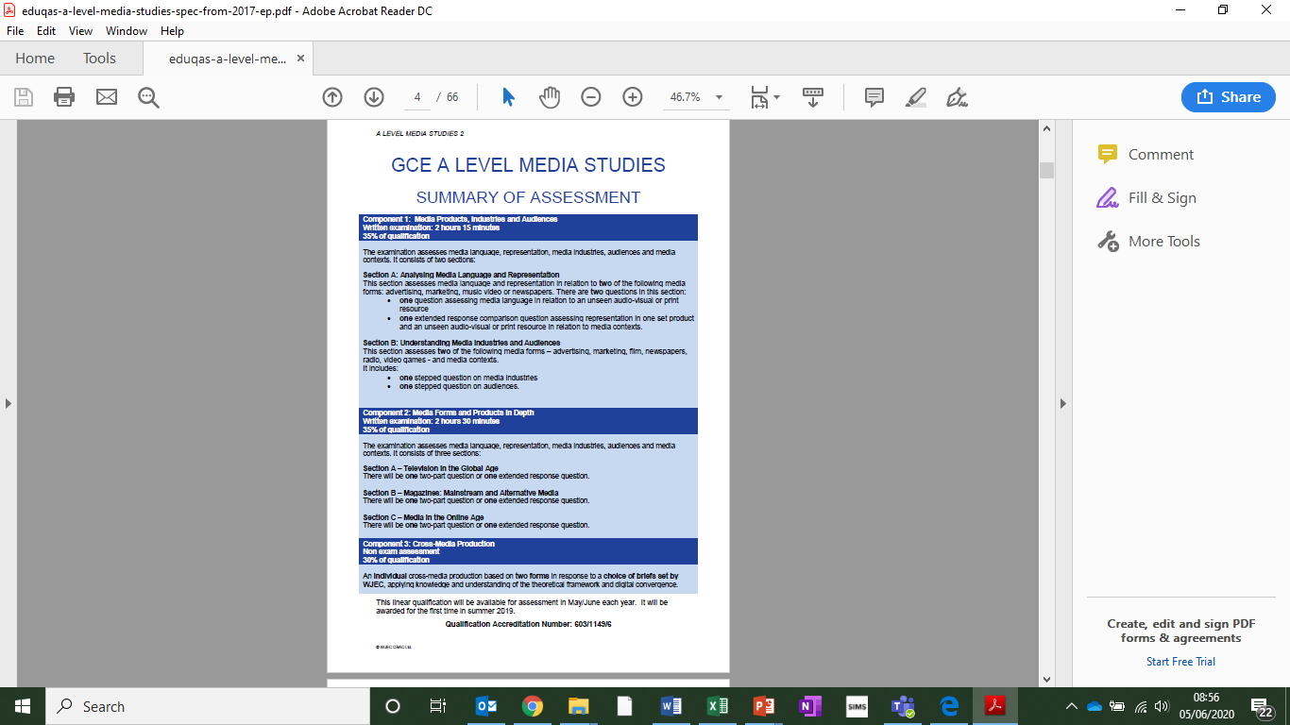

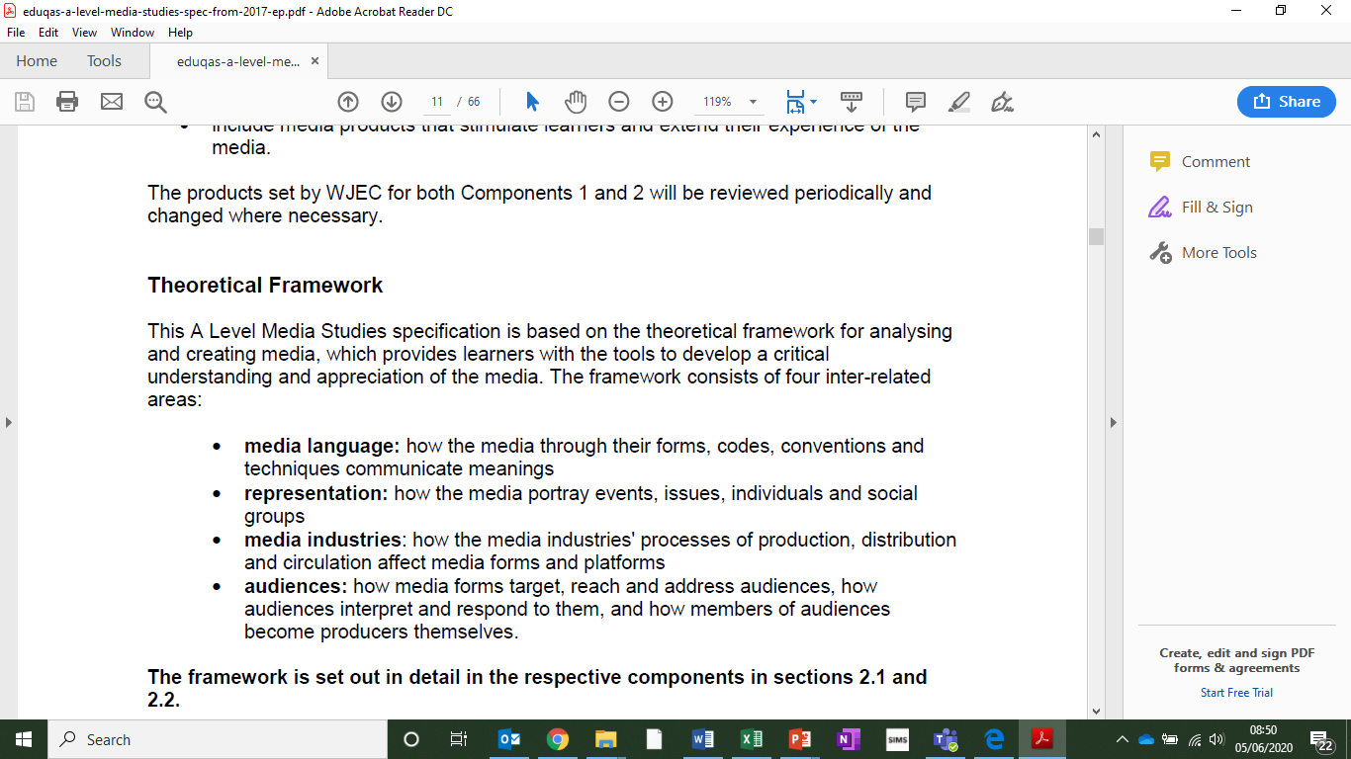

**MEDIA STUDIES PRE-COURSE TASKS:**

Two important skills in the study of Media Studies are the understanding of how a character drives a narrative and the ability to analyse a Media text.

**Task One:**

Choose your favourite character from any TV show or movie. Create a profile for this character which provides detail about the character’s personality and their importance to the story.

Things to include:

* Name/Age/Gender
* Nationality/Ethnicity
* Likes/Dislikes
* Strengths/Weaknesses
* How this character impacts the story

**Task Two:**

Choose a scene which includes your character and write a detailed analysis of the techniques used in the sequence.

Consider the effect on the audience of each of the following:

* Camerawork
* Sound
* Mise-en-scene
* Editing
* Representation of people or places

**You could use visual screen shots to demonstrate your points.**

**Helpful Links:**

<https://www.youtube.com/watch?v=BFwMRVwrKcA>

<https://www.youtube.com/watch?v=GQFszMu0Q_s>

<https://www.youtube.com/watch?v=J_IWEAUNdZ8>