Year 8 History Project
2019-20
(Weeks 1-4)
Part 1
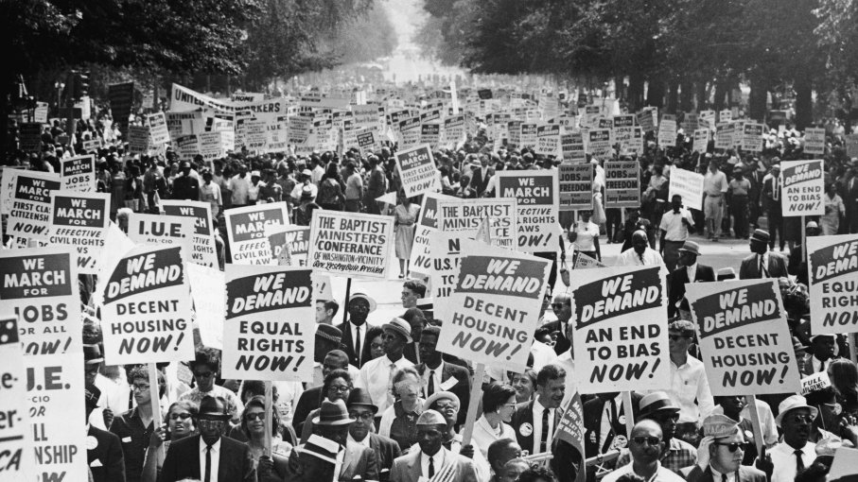
The American Civil Rights Movement

Student Name:
Teacher:

During this term you will be putting together a research project on the Civil Rights Movement in the United States of America.

During the course of this project, you will need to complete all lesson tasks on Microsoft Word documents or alternative programs (e.g. Pages for Mac users).

All tasks will be highlighted in yellow and must be completed in full sentences or according to how they would usually be completed in lessons.

You will need access to the internet for the lessons planned below

Lesson 1
Title: Abolition and Reconstruction

Starter: Create a table on your document containing a list of everything you know about slavery. Use the knowledge you have gained from our studies in Terms 1&2.

Task: Using the internet, define the following terms:
- Abolition
- Reconstruction
Task: Research question
Q: What led to the abolition of slavery in America in 1865?
Q: What is the 13th Amendment and what did it mean for American slaves?
Source A: A sharecropper farm in Arkansas in 1935.
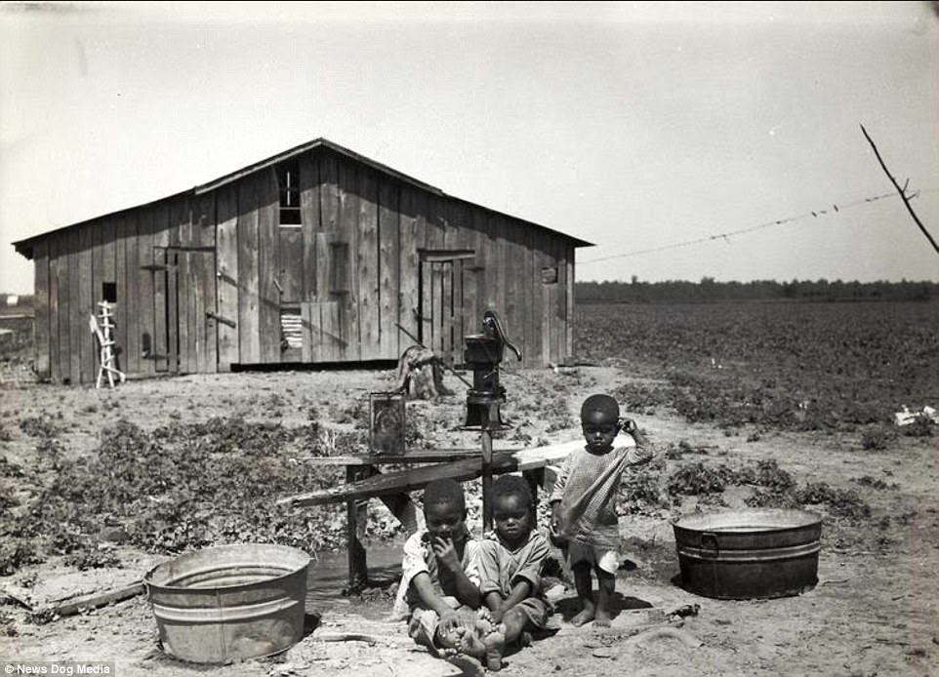
Task: What does this source tell us about the treatment of African Americans after the reconstruction period?

Lesson 2
Title: The Great Migration North

Starter: Thinking time: Based on what you know from last lesson, write a short paragraph on how black Americans were treated after the American Civil War.

Task 1: Research.
- Using the internet as a research aid, create a large mind-map which contains information and answers to the following questions:

- What was the Great Migration North?
- How many people took part in it and when?
- What made them leave their homes?
Task 2:
Create a table on your document like the one below. Using the internet as a research aid, find evidence which supports the idea that the Great Migration North improved the lives of black Americans as well as evidence that it did not.
Life got better | Life did not get better

Task 3:
Using the information gathered, answer the following question: ‘Life for black Americas improved after the Great Migration North. How far do you agree?
Lesson 3
Title: The Murder of Emmet Till
Starter: How do you think black children were treated in America? Write down your thoughts in a small paragraph.
Task 1: This lesson is going to focus on one of the most shocking events in American history: the murder of 14 year-old Emmett Till.
You are a reporter in America in 1955 who has been asked to cover the story of Emmett Till’s murder. Using Microsoft Word, you must create a newspaper article which includes the following information:
- Who was Emmett Till?
- Where did he live? How did he die?
- Who was suspected of killing him?
- Why is this event so significant in American history?
- How could this murder impact on race relations?
You must include the following in your newspaper article:
- A headline and an accurate date.
- Accurate information properly presented in formatted paragraphs.
- Quotations from an eyewitness or a local community figure (the local Mayor, Sheriff, etc)
- A captioned image

This task can also be done on A4 paper if this is more convenient. If you are completing this task on paper, please make sure that it is either scanned or photographed and sent to your teacher via email.

Lesson 4
Title: The Jim Crow Laws
Interpretation B- Michael Shepherd, 1998
As oppressive as the Jim Crow era was, it was also a time that many black community members around the country stepped forward into leadership roles to vigorously oppose the laws. The laws gave black communities a sense of something to fight against, they bound people together and drove them forward to campaign for significant change
Starter: Using the internet to find information, write a definition on your document defining what the Jim Crow Laws were and how they affected black Americans.
Interpretation B- Michael Shepherd, 1998
As oppressive as the Jim Crow era was, it was also a time that many black community members around the country stepped forward into leadership roles to vigorously oppose the laws. The laws gave black communities a sense of something to fight against, they bound people together and drove them forward to campaign for significant change.
Interpretation A- History today- 2018
For the next 15 years, local government, as well as the national Democratic Party and even President Andrew Johnson thwarted efforts to help the freed slaves move forward.
Violence was on the rise, making danger a regular aspect of black lives. Black schools were vandalized and destroyed, and bands of violent whites attacked black citizens in the night.
These were sometimes gruesome incidents where the victims were tortured and mutilated before being murdered. Families were attacked and forced off their land all across the South.

Task 1: Read the above interpretations. In what ways to these two interpretations differ? How do you know? Your answer must be detailed and include quotations from the interpretations. Remember to focus only on how they are different.

Task 2: For this task, you should read up on the Jim Crow Laws and make sure that you have an understanding of these.
After you have done this, imagine that you are a black American living in the mid-20th century. You are writing to a friend overseas and in your letter you must explain the following to them:
- What it is like to be a black person living in the United States of America;
- How your life is impacted by the Jim Crow Laws and how this makes you feel;
- What you believe needs to change and how this could begin to happen.

