Independent Reading Project
Independent Novel Project

An independent novel project will involve you reading a novel and then completing a series of activities for Home Learning. For each task, you need to select one from the category; each task has a star rating which will help you identify the level of challenge. Once each activity either on paper or on your computer and you can share with your teacher upon your return to school.

If you complete all the tasks then complete as many of the challenge tasks at the end as possible.

Key skills you are developing:

- To develop the ability to read, understand and respond to a literary text.

- To produce an Independent Novel Project that demonstrates an ability to respond to the text using textual evidence as appropriate.

Tasks
Reader Response 1
Reader Response 2
Vocabulary
Character study
Creative Writing
Book Talk
- Reading Journal

You need to create a detailed reading journal and complete two reader responses which needs to be ¾ to a full page each. Responses should answer/address the following questions but need to be written in paragraph form.

Reader Response 1

- Where is your novel set? Think about the time and place.
- Name and describe the main character in the novel. Describe him/her physically and describe his/her personality (and history if known). Then give your impression of him/her.
- Name and describe a secondary character in the novel. Describe him/her physically and describe his/her personality (and history if known).
- Explain the relationship between the two characters.
- Describe one important event in the novel and explain why it is significant to the story (to the plot, the characters or ideas of the book.)
- What are your thought and feelings about the novel so far?

Reader Response 2

- If the time and place changes in the novel, explain how and give examples. Why does this change happen? How does it help the novel develop?
- Who is the narrator in the story? Is he/she inside or outside the story? What is his or her relationship to the story?
- What is the general theme or mood of the book? Give specific examples of how the author creates that idea or mood.
- Give an example of conflict or conflicts between: i) two people ii) a person and his/her conscience (internal conflict) iii) a person and society/animal/nature/supernatural being.
- What is your reaction to a relationship, event, behaviour or message/theme of the book. Be clear about what you are reacting to and exactly what makes you respond as you do.
- Choose a sentence or phrase that appeals to you. Explain why you chose it, it’s relation/value to the book and its value to you.
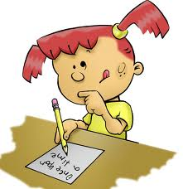

Guidance for Reading Journals

Category | Not within expectation | Approaching Expectations | Meeting or exceeding Expectations
Ideas/Content | Entries do not show reflections about readings. The connections do little to help me understand the story. Reading journal is incomplete. | Entries include some reflection of readings but also lots of summaries. Reading journal is almost complete. | Entries show evidence of reflection of readings and original ideas, not summaries. Reading journal is completed in accuracy and in detail
Evidence From Novel | Not enough detail is included in examples from the novel to show the reader what part of the novel is being discussed. | Examples and references from the novel are provided but more detail is required. | Examples and references from the novel are provided in detail where necessary.
Fluency | Journals are difficult to read and understand. | Journals are mostly easy to read and understand. | Journals are thoughtful and imaginative.
Quantity and Presentation | Journal entries are not of the required length. Presentation makes the journal difficult to follow/read. | One journal is not quite long enough. Presentation is adequate. Journals are fairly neatly presented, titles have been included. | All journal entries meet/exceed the required length. Presentation is very clear. Journals are neatly written or typed. A title has been included for each entry.

2. Vocabulary

Choose one of the following assignments. Include a title and any necessary headings.
- Vocabulary Log: Choose at least 15 words from your novel that you do not know the meaning of. Record the dictionary definition of each word.
= | - Create a Thesaurus. List 20 words that seem overused or boring. Rewrite the sentence from the book in which the word was found with a better one.
- List 15 interesting, important or unusual words from your book and explain your reasons for choosing each word.

- Create a crossword with 10 words across and 10 down. Provide a clue for each word and the answer key.

- Create your own assignment using 10-20 words in a creative way that shows you understand the meaning and are learning new vocabulary.

Guidance for Vocabulary

Category | Not within expectation | Approaching Expectations | Meeting or exceeding Expectations
Vocabulary selection | Selected words are simple, limited selection. | Some interesting or advanced words, some consideration taken when selecting. | Interesting or complex words. A wide selection.
Vocabulary Usage | Many words are incorrectly used. | Most of the words are used correctly in the assignment. | All words are used correctly in the assignment.
Presentation | The assignment is attempted but not completed correctly and/or is difficult to read and interpret. | The assignment is almost completed according to directions and is somewhat neatly presented. | The assignment is completed according to directions and is neatly presented.

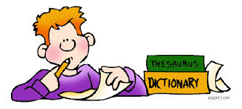

3. Character study

Choose one of the main characters that interest you, complete the boxes below with relevant quotations that will help you create a character study.

Make a list of quotations that provide you with factual information about the character e.g. age, address, appearance, friends, family etc

Make a list of things that other people say about the character, and explain what this reveals to you as the reader about them.
What they say | What this suggests about the character

Make a list of things that the main character says or does, then explain what this reveals to us about the character
What they say | What this implies about the character

Now use your notes to write up your inferences in full paragraphs. Use the example below to help you.

Make a list of things that other people say about the character, and explain what this reveals to you as the reader about them.
What they say | What this tells us about the character
Smiling evilly, he went through all the bags in the room and put all the money he could find into his pockets. | The character is a thief and does not feel guilty about stealing from others.

Sebastian is not a likeable character, we can tell this when he decides to steal from his friends and enjoys doing it as well. When “he went through all the bags in the room and put all the money he could find into his pocket,” he was described as “smiling evilly.” This would suggest to the reader that Sebastian does not seem to care about how upset his friends will be feeling when they realise they have been robbed and also that he does not feeling guilty at all.

Your character study needs to include at least three detailed paragraphs about your chosen character. Remember to choose your quotations carefully, and explain in detail the writer’s use of language.

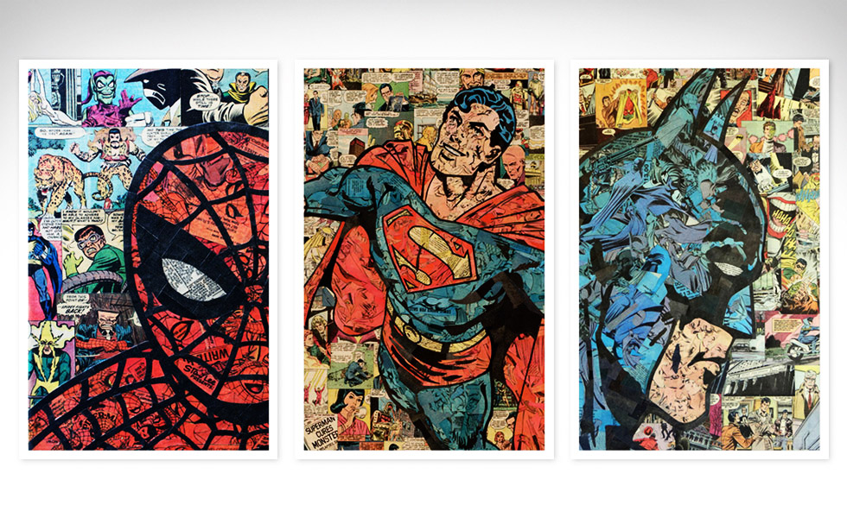

4. Creative Writing

Choose one of the following assignments. Include a title and any necessary headings.
- Imagine that you are a character in your novel; you can choose any character who interests you (it doesn’t have to be the main character). Write a diary entry as that character as the story unfolds. Include 3 diary entries.
- Write an interview (with the answers) with one of the major characters, exploring the main event of the novel.
- Write an obituary for one of the main characters.
- Write a newspaper article about an event that has happed in your book.
- Write a poem inspired by your novel (can be about a character, event, setting etc.)
- Describe an experience you (or someone else you know) had that was like the experience of a character in the book.
- Challenge Tasks

The activities listed below are optional and can only be completed once all other tasks are complete.
- Interview a character from your book. Write at least ten questions that will give the character the opportunity to discuss his/her thoughts and feelings about his/her role in the story. However you choose to present your interview is up to you.
- Write a diary that one of the story’s main characters might have kept before, during, or after the book’s events. Remember that the character’s thoughts and feelings are very important in a diary.
- Write a sales talk, pretending the students in the class are clerks in a bookstore and you want them to push this book.
- Make several sketches of some of the scenes in the book and label them.
- Imagine that you are the author of the book you have just read. Suddenly the book becomes a best seller. Write a letter to a movie producer trying to get that person interested in making your book into a movie. Explain why the story, characters, conflicts, etc., would make a good film. Suggest a filming location and the actors to play the various roles.
- Write a book review as it would be done for a newspaper. (Be sure you read a few before writing your own.)
- Write a feature article (with a headline) that tells the story of the book as it might be found on the front page of a newspaper in the town where the story takes place.
- Write a letter (10-sentence minimum) to the main character of your book asking questions, protesting a situation, and/or making a complaint and/or a suggestion. This must be done in the correct letter format.
- If the story of your book takes place in another country, prepare a travel brochure using pictures you have found or drawn.
- Write a FULL (physical, emotional, relational) description of three of the characters in the book. Draw a portrait to accompany each description.
- After reading a book of history or historical fiction, make an illustrated timeline showing events of the story and draw a map showing the location(s) where the story took place.
- Compare the plot or characters of the book that you are reading with another book or character within a text.
- Write an essay comparing the movie version with the book.
- Create a mini-comic book relating a chapter of the book.
- Write an original song that tells the story of the book.
- Be a TV or radio reporter, and write a script report of a scene from the book as if it is happening "live".
- Design a book cover for the book. I STRONGLY suggest that you look at an actual book cover before you attempt this.
- Create a newspaper for your book. Summarize the plot in one article, cover the weather in another, do a feature story on one of the more interesting characters in another. Include an editorial and a collection of ads that would be relevant to the story.
- Write about what you learned from the story.
- Write a different ending for your story. Explain your choice of resolution and how you want your reader to feel or learn as a result.
- Write a different beginning for your story. Explain your choice of language or point of view.
- Compare and contrast two characters in the story.
- Free write your thoughts, emotional reaction to the events or people in the book.
- Make a flow chart of all the events in the book.
- Make a message board of the characters’ thoughts or reactions.
- Complete a character mapping, showing how characters reacted to events and changed.
- Make a character tree, where one side is event, symmetrical side is emotion or growth.
- Choose a quote from a character. Write why it would or wouldn’t be a good motto by which to live your life
- Learn something about the environment in which the book takes place.
- Retell part of the story from a different point of view
- Choose one part of the story that reached a climax. If something different had happened then, how would it have affected the outcome?
- Create a ‘if you like this book you should read…’ list for your book.

